Dylan Olthoff, Rylan Casanova

CST-310

Professor Citro

##### **Project 8: Simple Demo Scene**

**Flappy Bird:**

In this project we are tasked with making a project in C++ and OpenGL and are not limited to what we create. We are tasked with making an animation or a demo scene that is based on a nonlinear mathematical function or a set of functions. Since the project is open ended besides us having to create something in C++ and in OpenGL, we have decided to create a mimic of the popular game flappy bird. In flappy bird your goal is to bounce through the opening between the objects that are sliding towards you on the screen. When you hit any of the objects and fail to pass through them, the game will end. Also, we needed to use mathematical functions including basic acceleration, velocity, and position functions to calculate the bird’s movement. Our implementation for the project is as shown below.

**Implementation:**

In our project we needed to add support to allow the player to jump and dodge the obstacles that come flying at them. To add the functionality for this we made it so that the player could jump and avoid these obstacles by pressing the ‘f’ key on their keyboard. With this mechanic the player is able to flap their wings and dodge the obstacles for as long as they can before they hit one and the game ends.

The other aspect of the game includes the spawning of the obstacles for the player to jump through. We do this by spawning in two tubes one above the other which then translate across the screen until they get reset to the right of the camera (outside of the player’s view distance) when they pass off the left side of the screen. The tubes are randomly generated in height using the rand() function. Additionally, every time the player passes through an obstacle successfully, they score 1 point. This player’s final score is given when the game ends and is outputted in the console.

**Flowchart:**

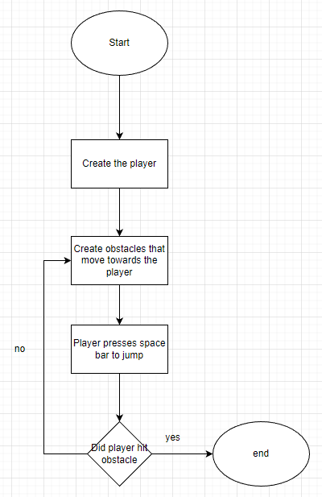

**Video demonstration:**

[**https://www.loom.com/share/e23ade2f885040aabe38aa552fe56d06**](https://www.loom.com/share/e23ade2f885040aabe38aa552fe56d06)

**Screenshots of program running:**

